**Lab Task 5**

**My Application: BMI Calculator**

**Objective:**

* Apply calculation in mobile application
* Apply decision control in mobile application

1. Create an interface shown as below:

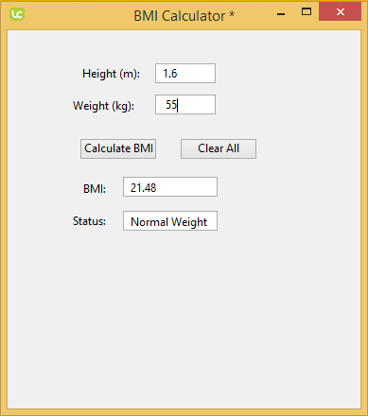

1. Add the following objects:

* Label 1 : Height (m) -> name: lHeight
* Label 2: Weight (kg) -> name: lWeight
* Label 3: BMI -> name: lBMI
* Label 4: Status -> name: lStatus
* Field 1: name: tHeight
* Field 2: name: tWeight
* Field 3: name: tBMI
* Field 4: name: tStatus
* Push Button: Calculate BMI -> name: cBMI
* Push Button: Clear All -> name: clearBtn

1. Add the following code for the object push button named *cBMI*:

|  |
| --- |
| **global** varheight  **global** varweight  **global** varbmi  **global** varheight2  **on** mouseUp  **put** 0.0 into varheight  **put** 0.0 into varweight  **put** 0.0 into varbmi  **put** 0.0 into varheight2  **put** field "tHeight" into varheight  **put** field "tWeight" into varweight  **put** (varheight * varheight) into varheight2  **put** varweight / varheight2 into varbmi  **put** round(varbmi,2) into varbmi  **put** varbmi into field "tBMI"    **if** varbmi < 18.5 **then**  **put** "Underweight" into field "tStatus"  **else** **if** varbmi < 25 **then**  **put** "Normal Weight" into field "tStatus"  **else** **if** varbmi < 30 **then**  **put** "Overweight" into field "tStatus"  **else** **if** varbmi >= 30 **then**  **put** "Obese" into field "tStatus"  **end** **if**  **end** mouseUp |

1. Add the following code for the object push button named *clearBtn*:

|  |
| --- |
| **on** mouseUp  **put** " " into field "tHeight"  **put** " " into field "tWeight"  **put** " " into field "tBMI"  **put** " " into field "tStatus"  **end** mouseUp |

1. Finally open the standalone settings for your app. Click File -> Standalone Application Settings.
2. Now save the app as a standalone. Click File -> Save as Standalone Application.
3. Go to the folder where you saved your app and open it. You may choose one either Windows, Mac or Linux depending on the machine you are on, select an app to run.
4. Now you have an app that runs on its own on your desktop.

**Tutorial Question:**

Create a mobile application on GPA calculator. The calculator must be able to calculate GPA according to KUPTM academic regulation. The application must able to do the following:

1. Ability to add or remove one or more than one course.
2. Ability to calculate GPA (for current semester)